Table A: Comparison by Infection

TC "The Report Procedure "TC "Detailed and/or summarized report "TC "Table 1 "Characteristic | Overall  (n=1053) | No  (n=1032) | Yes  (n=21) | p value
Primary Surgeon
Xerogeanes | 744/1053(70.7%) | 734/1032(71.1%) | 10/21(47.6%) | 0.017*
Labib | 115/1053(10.9%) | 113/1032(10.9%) | 2/21(9.5%)
Karas | 194/1053(18.4%) | 185/1032(17.9%) | 9/21(42.9%)
Contact Related
Yes | 361/1004(36.0%) | 359/983(36.5%) | 2/21(9.5%) | 0.010*
No | 643/1004(64.0%) | 624/983(63.5%) | 19/21(90.5%)
Age
Mean ± SD (N) | 31.1 ± 10.9(1052) | 31.2 ± 10.9(1031) | 28.7 ± 9.7(21) | 0.31
Median[Q1-Q3] | 29.0[22.0 - 39.0] | 29.0[22.0 - 39.0] | 25.0[21.0 - 33.0]
[Min-Max] | [3.0 - 66.0] | [3.0 - 66.0] | [19.0 - 47.0]
Sex
Male | 644/1053(61.2%) | 633/1032(61.3%) | 11/21(52.4%) | 0.50
Female | 409/1053(38.8%) | 399/1032(38.7%) | 10/21(47.6%)
Tourniquet Time (mins)
Mean ± SD (N) | 60.1 ± 29.4(1051) | 60.2 ± 29.1(1030) | 56.0 ± 42.6(21) | 0.86
Median[Q1-Q3] | 60.0[45.0 - 80.0] | 60.0[45.0 - 79.0] | 59.0[0.0 - 89.0]
[Min-Max] | [0.0 - 145.0] | [0.0 - 145.0] | [0.0 - 130.0]
Positions
Bolster | 194/1053(18.4%) | 185/1032(17.9%) | 9/21(42.9%) | 0.0078*
Lithotomy | 859/1053(81.6%) | 847/1032(82.1%) | 12/21(57.1%)
Retear
Yes | 60/1053(5.7%) | 60/1032(5.8%) | 0/21(0.0%) | 0.63
No | 993/1053(94.3%) | 972/1032(94.2%) | 21/21(100%)
Contralateral Tear
Yes | 20/1053(1.9%) | 19/1032(1.8%) | 1/21(4.8%) | 0.33
No | 1033/1053(98.1%) | 1013/1032(98.2%) | 20/21(95.2%)
LOA_MUA
Yes | 55/1053(5.2%) | 49/1032(4.7%) | 6/21(28.6%) | 0.0005*
No | 998/1053(94.8%) | 983/1032(95.3%) | 15/21(71.4%)
Meniscectomy
Yes | 48/1053(4.6%) | 47/1032(4.6%) | 1/21(4.8%) | 1.00
No | 1005/1053(95.4%) | 985/1032(95.4%) | 20/21(95.2%)
Hematoma
Yes | 8/1053(0.8%) | 8/1032(0.8%) | 0/21(0.0%) | 1.00
No | 1045/1053(99.2%) | 1024/1032(99.2%) | 21/21(100%)
tibialis anterior allo
Yes | 478/1053(45.4%) | 469/1032(45.4%) | 9/21(42.9%) | 1.00
No | 575/1053(54.6%) | 563/1032(54.6%) | 12/21(57.1%)
BTB
Yes | 162/1053(15.4%) | 156/1032(15.1%) | 6/21(28.6%) | 0.12
No | 891/1053(84.6%) | 876/1032(84.9%) | 15/21(71.4%)
HT
Yes | 233/1053(22.1%) | 231/1032(22.4%) | 2/21(9.5%) | 0.19
No | 820/1053(77.9%) | 801/1032(77.6%) | 19/21(90.5%)
BTB Allo
Yes | 64/1053(6.1%) | 62/1032(6.0%) | 2/21(9.5%) | 0.37
No | 989/1053(93.9%) | 970/1032(94.0%) | 19/21(90.5%)
HT Allo
Yes | 101/1053(9.6%) | 99/1032(9.6%) | 2/21(9.5%) | 1.00
No | 952/1053(90.4%) | 933/1032(90.4%) | 19/21(90.5%)
Achilles_allo
Yes | 2/1053(0.2%) | 2/1032(0.2%) | 0/21(0.0%) | 1.00
No | 1051/1053(99.8%) | 1030/1032(99.8%) | 21/21(100%)
Quad
Yes | 10/1053(0.9%) | 10/1032(1.0%) | 0/21(0.0%) | 1.00
No | 1043/1053(99.1%) | 1022/1032(99.0%) | 21/21(100%)

Fixed Scenario Elements
Distribution | Exact conditional
Method | Walters normal approximation
Number of Sides | 2
Group 1 Proportion | 0.0114
Group 2 Proportion | 0.0464
Group 1 Sample Size | 859
Group 2 Sample Size | 194
Alpha | 0.05

Computed Power
Power
0.721

proc logistic data=op descending plots(only)=roc(id=obs);;
class pos proced sex contact LOA_MUA BTB/param=ref ref=first;
model infection=age pos sex LOA_MUA BTB/lackfit;
run;

Type 3 Analysis of Effects
Effect | DF | Wald  Chi-Square | Pr > ChiSq
age | 1 | 0.0010 | 0.9749
pos | 1 | 9.2117 | 0.0024
sex | 1 | 0.3759 | 0.5398
Loa_mua | 1 | 15.5597 | <.0001
BTB | 1 | 1.3449 | 0.2462

Odds Ratio Estimates
Effect | Point Estimate | 95% Wald  Confidence Limits |  | P value
age | 0.999 | 0.951 | 1.050 | 0.9725
pos Lithotomy vs Bolster | 0.230 | 0.090 | 0.589 | 0.0022
sex Male vs Female | 0.744 | 0.294 | 1.879 | 0.5312
Loa_mua Yes vs No | 8.440 | 2.913 | 24.455 | <0.0001
BTB Yes vs No | 1.986 | 0.630 | 6.256 | 0.2414

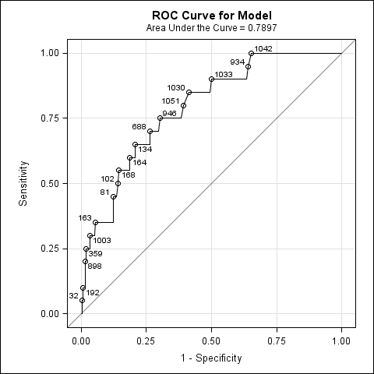

Hosmer and Lemeshow Goodness-of-Fit
Test
Chi-Square | DF | Pr > ChiSq
5.3771 | 8 | 0.7166

